FULL NAME  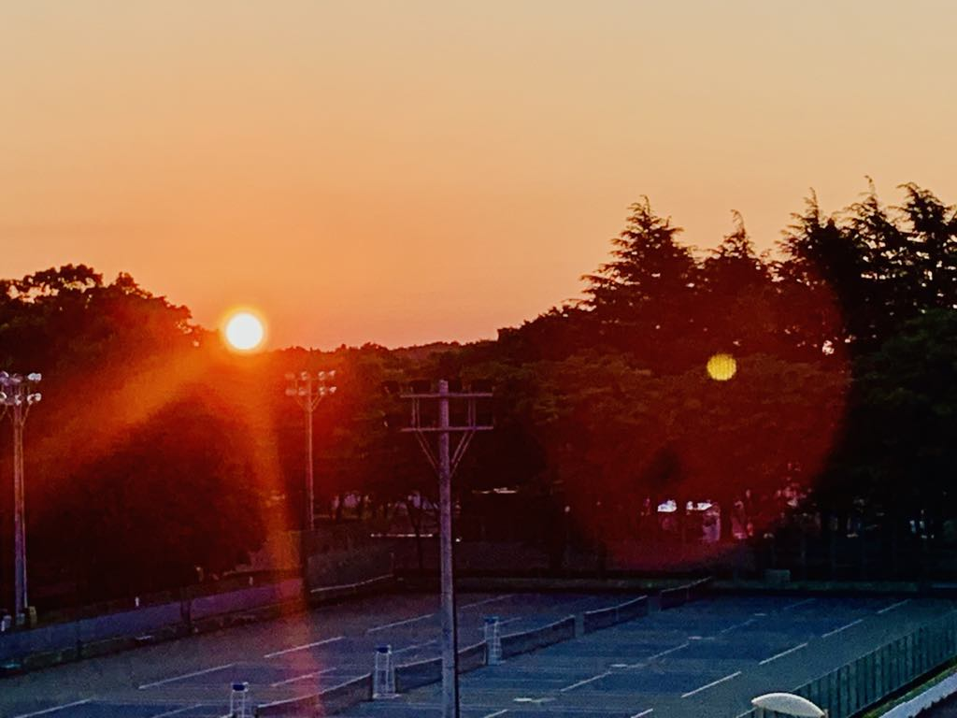  ADD A SELF PHOTO IF OK- IF NOT, ADD A PHOTO THAT REPRESENTS YOU/INTEREST  PHONE:  +81 or 91 ----  WEBSITE:  University of ……  Web link of program or school  EMAIL:  xyz@gmail.com or University ID  Short Summary: Bachelor’s student at the University of Tsukuba, Japan. Passionate and detail-oriented with an upcoming bachelor’s in Health and Sport Sciences (2025), NAME is driven to contribute to the success of Women’s Goalball through sports business, sports sustainability, and strategic promotion to attract fans. With a strong passion for the local community and engagement options for youth regardless of gender, NAME is eager to apply her knowledge in sports and management (including events) skills to create meaningful and enjoyable sports experiences for ALL. Her academic background and growing international experience have equipped her with the skills to foster cross-cultural connections, promote active lifestyles, and support the local women's goalball program.  Interests  Goalball  Women’s Goalball  Sports Business  Sustainable Sports  Local Sports team  Multi sports  Travel  Etc…  Goals for the Future:  (Maybe one 1 or more  1. FULL NAME would like to gain a deeper understanding of the structure and environment of the sports business for women's goalball outside Japan, particularly how is women's goalball being integrated into society as a sustainable sports business model, the level of support provided, and the balance between strengthening and popularizing women's goalball.  2. FULL NAME career goal is to be a management staff for the Japan Goalball Football Union. Regarding her future dream, she would like to have opportunities in the goalball football team or the union and contribute to the success of the Women's Goalball World Cup in Japan.  3. Through her experiences in both Japan and the world, NAME aspires to CONNECT sports & people and be a BRIDGE between the two countries. NAME hopes to gain new opportunities and knowledge to develop a broader international perspective, and in the future, she aims to give back (all that she has learned and will learn) by supporting young children through SPORTS. |  | EDUCATION  B.A./B.Sc./Etc. (Full Program Name), University of Tsukuba, Japan, 2020 – 2024; graduation expected (2024) (if Graduate student add below) ALL BELOW IS AN HYPTHETICAL EXAMPLE  Experience (can be ANYTHING including partime)  [Program Name or Work Place, Country] (2000 Apr – 2000 Mar)  - Women’s Goalball Team - Played in matches as a wing player from the first year.  - As head of the PR team, NAME created posts and determined the frequency of posts to increase the number of supporters for the team, managed social media, and significantly increased the number of followers.  - As a position leader, NAME provided feedback on the performance of individual players and the team and created effective training menus.  [Program Name or Work Place, Country] (2000 Apr - Present)  - Representative, from launch to running the team.  - Recruited local sponsors for uniform production and set up a place to display them.  - Create and design uniforms and practice shirts.  - Fostered a passion for Women's goalball and ensured that children and people from the local community had an environment, including vocal encouragement, allowing women's players to perform at their best.  [Program or Experience location, Country] (2000 Oct - present)  - Manage social media posts for the children's language school.  - Create videos and posts using apps to promote the language school.  - Communicate effectively with a language school teacher in English to manage the posts according to their requests.  - master's thesis.  [Program or Experience location, Country] (2000 Mar - present)  - Help to prepare and serve a variety of high-quality, handcrafted udon noodles at a popular restaurant that has been featured on national TV.  - Provided exceptional customer service by creating a welcoming environment and personalizing each guest’s experience.  - Maintained efficiency in a fast-paced environment, ensuring quick and accurate order fulfillment.  - Managed cash handling and mobile orders with accuracy.  - Maintained high cleanliness and hygiene standards, ensuring compliance with health and safety regulations.  - Worked collaboratively with team members to ensure smooth store operations and enhance the overall customer experience.  - Assisted in training new partners to uphold service and quality standards.  SKILLS  Language  Japanese [native]  English [B2]  IT skills  - Microsoft Office  Word, Excel, PowerPoint  - Team Management Tools  Slack, Teams  - Social Media  X, Facebook, Instagram, Snapchat  References: 1 or 3 (may be people from School or community)  Dr. Randeep RAKWAL, Ph.D.  Professor, Institute of Health and Sport Sciences, Tsukuba International Academy for Sport Studies (TIAS 2.0), Global Sport Innovation Bldg., Room 403, UNIVERSITY OF TSUKUBA, Tennodai, Tsukuba, Ibaraki 305-8574, Japan  e- plantproteomics@gmail.com , rakwal.randeep.fu@u.tsukuba.ac.jp  Mobile – (+81) 090-1853-7875 / Office phone – (+81)029-853-2681  Websites: https://tias.tsukuba.ac.jp , http://www.trios.tsukuba.ac.jp/en/researcher/0000003045
- NOTES: (what do my keywords actually mean?) (OWN PERSPECTIVE, not a standard definition of the KEYWORDS YOU CHOOSE TO WRITE BELOW)

Goalball – is a sport of diversity and cooperation, a socially important skill. Players of various physiques come and work hard together towards one goal (score points). With goalball, I was able to meet many people from Japan and overseas, and this made me grow as an individual. I would like many children to play goalball.

Women’s Goalball – in Japan tends to be a male-dominated sport. Men have many options to continue playing goalball and can choose a school or balance work and goalball. In addition, the men's national team matches are very popular, and the revenue supports the entire sport as a sports business. On the other hand, women have fewer competitive environments and career options, and there are fewer spectators at Japan national team matches, so they are not financially independent, and I see these as problems. On a personal note, I was also asked not to play goalball in college, and I choose to play it outside, it was not easy, but it made me what I am today.

Sports Business – Currently, most women's goalball matches in Japan are free to watch, and even when priced, they are quite cheap; still, they do not attract many spectators. Therein, a challenge going forward is how to develop women's goalball into a sports business sustainable model, and I would like to research on its growth, success, and progress.

Sustainable Sports – I think it is important to create an environment that makes children want to start and continue playing sports, socially, economically, and environmentally. To make sports sustainable, addressing the differences in the playing environment due to gender and economic disparities, and the avoidance of sports due to environmental issues, is key. In the case of “women and sports” it is now even more important to support such an environment that fosters the inclusion of girls (school and university) into goalball. Like me, it is heartening to see the number of women playing goalball increasing in Japan.

Local Sports Team – I have played goalball locally since I was a child. I did not have many opportunities to practice or play, so I dreamed of playing in the big city or abroad (New Zealand was one of my choices). For a start, local children who are going to lead the future should be able to play at will developing, and creating a sports environment whether it be for training or for recreation. With more women in sports and in goalball, I believe that financial independence for women's goalball will also translate to greater support for local clubs.

Multisport – I was lucky to be able to play different sports as a child, e.g., basketball, softball, badminton, T&F, handball, wrestling, football, swimming. Now as a graduate student studying in a sports university, I realize my experiences as a child playing a variety of sports has made me more aware of their value (i.e., diversity in movement and action, which I think has helped me as a goalball player).

Travel – I sometimes travel all over Japan and abroad. Seeing the new scenery and meeting and talking with local people can be opportunities to break away from the stereotypes of everyday life and greatly broaden my horizons and way of thinking. I enjoy traveling with friends and family, but I also love traveling alone because I can flexibly change the time and itinerary, and be myself.

Content created by: Prof. Randeep RAKWAL (as part of the ‘MAGIC’ initiative: ©MAGIC = Society for Investing in Practical Communication Learning and Mentoring by INSPIRING COMMUNICATIONS; co-founder = Atsumi SHIGEMATSU) – An outcome of the “global communication skills training” course of the GGEC (Graduate General Education Courses) program of University of Tsukuba.

